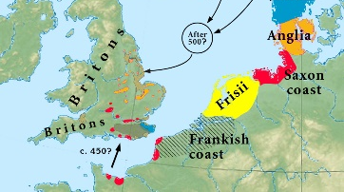
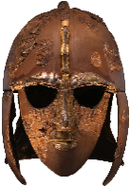
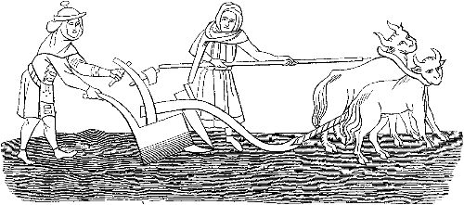
England
(Europe)
Anglo-Saxons
 | Key Vocabulary
Bayeux Tapestry | 70m long embroidered cloth depicting the events leading up to the Norman conquest.
Beowolf | An Old English epic story consisting of 3182 alliterative lines written in c975-1010.
Lindisfarne | A monastery in northern England where Vikings first landed and attacked from Scandinavia.
lyre | A five to seven stringed musical instrument used in northern Europe.
mead | An alcoholic beverage made from honey, water and yeast, often with spices and herbs.
Offa’s Dyke | A larger linear earthwork on the border of Wales and England ordered by King Offa.
runes | Alphabet consisting of between 26-33 letters used to write Old English.
Sutton Hoo helmet | A decorated Anglo-Saxon bronze helmet excavated in1939 buried around 625.
thatch | The craft of building a roof with dry vegetation such as reeds and straw.
wattle-and-daub | The weaving of small wooden branches with mud, straw, horse hair and dung to create walls.
Timeline
410 | 497 | 575 | 586 | 597 | 757 | 793 | 871 | 1016 | 1066
Romans left Britain leaving it unguarded | The kingdom of Wessex is formed | The kingdom of East Anglia was formed | The Kingdom of Mercia is formed | St Augustine introduces Christianity | Offa King of Mercia declares himself King of England | Vikings attack Lindisfarne | Alfred the Great rules | Canute the Great rules as first Viking | Battle of Hastings Normans defeat the Saxons
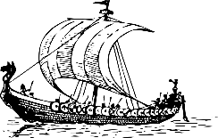
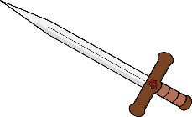
A famous Anglo-Saxon archaeological site is Sutton Hoo, where a whole ship was used as a grave! An Anglo-Saxon king was buried inside the ship along with some of his possessions, such as his helmet and sword.
Famous Figures

Where did the Anglo-Saxons come from?
The Romans left Britain in 410 due to fierce tribes attacking Italy and every soldier was needed back at home to defend the country. Without an army of its own, it left the country vulnerable to attackers. The Anglo-Saxons came from Denmark, Netherlands and northern Germany across the North Sea in wooden boats. The conquered England but failed to conquer Scotland, Wales and Cornwall (an area of south-west England).

The Vikings
The Anglo-Saxons were under constant attack from Vikings who travelled from Scandinavia and invaded towns and villages in Wales, Scotland, England and the Isle of Man, finally conquering York (Jorvik) in 866. They finally defeated the Anglo-Saxons as the Normans (Norsemen) from Normandy (France) invaded and won the Battle of Hastings in 1066. The Normans in France were originally Vikings from Scandinavia!

General Knowledge

St Augustine (c.530-604)
Augustine of Canterbury was a Christian missionary sent from Rome to convert people from Anglo-Saxon paganism to Christianity. He was considered to be responsible for the widespread adoption of the Christian faith throughout England.
King Aethelbert (c.550-616)
King of Kent who created the first Germanic law code in the early 7th Century and became the first English king to convert to Christianity due to Augustine’s mission to convert people from paganism.
King Offa (c730-796)
King of Mercia, and of most of England in the mid-8th Century. Historians regard him as the most powerful Anglo-Saxon king until Alfred the Great.
King Alfred the Great (849-899)
Fought the Vikings and defeated them in the Battle of Edington (878) and thus made an agreement with them (Danelaw). He was known for improving the standard of living, legal and military systems as well as education.

