All Saints Upton CE Primary Religious Education Knowledge Organiser
Year Five Key Question: Where can we find guidance about how to live our lives?  Hinduism Key Question: What might Hindus learn from stories about Krishna? |  | Spring 1 Year 5
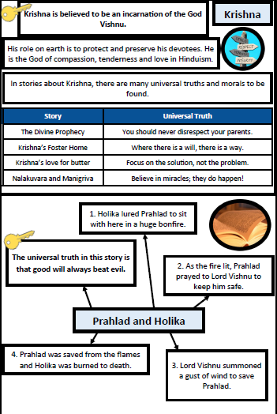 | 